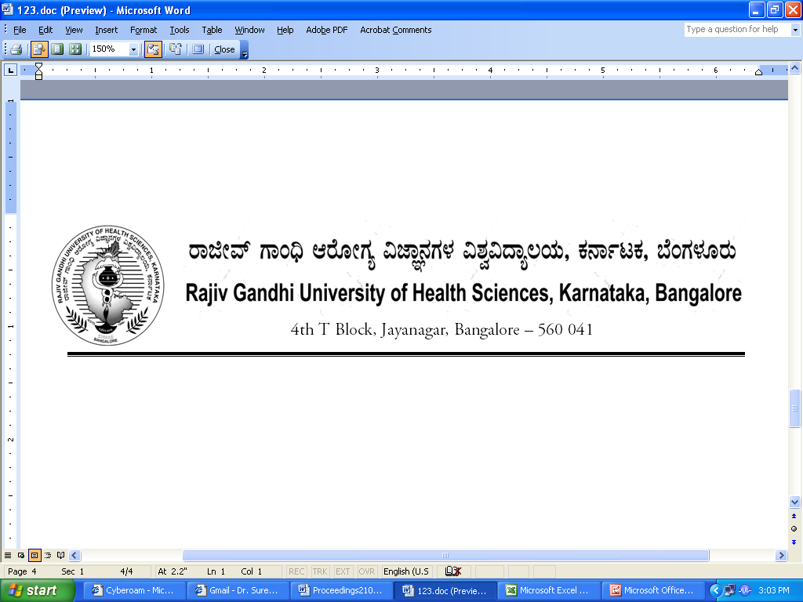
Reg(E)Exam/PG-AHS/April- 2018 Date: 27/02/2018

To,

The Director / Dean / Principals of
Allied Health Science Colleges
Affiliated to RGUHS.

Sir / Madam,

Sub : | Providing the number of students appearing for PG Practical Allied Health Science course examination April- 2018.

With reference to the above, you are hereby requested to send the number of students appearing April-2018 Post Graduate Allied Health Science practical examination same may be informed in the following proforma on or before 08/03/2018 through email:drexamrguhs@gmail.com without fail to speed up the examination process.
PG Allied Health Sciences

Name of the Student | Register No | Name of the Course

Thanking you,

Yours faithfully,

Sd/-
Registrar [Evaluation]

